

**S.Y.B.Sc**

**Computer Science**

**2019 – 2020**

**This is to certify that PRASHANT SINGH of S.Y.B.Sc Roll No. 70 has successfully completed the practical of Paper – V (sem – III)** **Combinatorics & Graph Theory during the Academic Year 2019-2020 as specified by the MUMBAI UNIVERSITY.**

**Prof. (Ms.) Mala Mishra. Prof. (Mrs.) Anita Gaikwad**

**Professor-In-charge In-charge**

**Dept. of Computer Science Dept. of Computer Science**

Name : PRASHANT SINGH

Roll no: 70

Subject : Combinatorics and Graph Theory (Paper-V)

Class : S.Y.BSc. (COMPUTER SCIENCE)

Academic Year : 2019-2020

|  |  |  |  |  |
| --- | --- | --- | --- | --- |
|  |  | **INDEX** |  |  |
| **No** | **Date** | **TITLE** | **Page**  **No** | **SIGN** |
| 1 | 17/06/2019 | Write a Python program on strings, sets and binomial coefficients. |  |  |
| 2 | 24/06/2019 | Solving problems using induction. |  |  |
| 3 | 28/06/2019 | Write a Python program on Eulerian graphs. |  |  |
| 4 | 05/07/2019 | Solving problems on Hamiltonian graphs. |  |  |
| 5 | 12/07/2019 | Solving problems using Kruskal’s Algorithm |  |  |
| 6 | 19/07/2019 | Solving problems using Prim’s Algorithm |  |  |
| 7 | 26/07/2019 | Solving problems using Dijkstra’s Algorithm |  |  |
| 8 | 02/08/2019 | Solving problems on Bell-Man Ford Algorithm |  |  |
| 9 | 09/08/2019 | Solving problems on network flows using Ford-Fulkerson Labeling Algorithm |  |  |
| 10 | 16/08/2019 | Solving Problems on Travelling Salesman Problem. |  |  |

**PRACTICAL - 1**

**WRITE A PYTHON PROGRAM ON STRING , SETS AND BINOMIAL**

**COEFFICIENT:**

SOURCE CODE:

STRING.PY

string1="Ramniranjan College"

print("initial string:")

print(string1)

print("\n first character of string is:")

print(string1[0])

print("\n last character of string is:")

print(string1[-1])

print("\n slicing character from 3-12:")

print(string1[3:12])

print("\n slicing character between"+"3rd and 2nd last character:")

print(string1[3:-2])

OUTPUT:

initial string:

Ramniranjan College

first character of string is:

R

last character of string is:

e

slicing character from 3-12:

niranjan

slicing character between3rd and 2nd last character:

niranjan Colle

SOURCE CODE:

SET.PY

set1=set()

set2=set()

for i in range(1,6):

set1.add(i)

for i in range(3,8):

set2.add(i)

print("set1=",set1)

print("set2=",set2)

print("\n")

set3=set1|set2

print("union of set1 and set2:set3=",set3)

set4=set1&set2

print("intersection of set1 and set2:set4=",set4)

print("\n")

if set3<set4:

print("set3 is superset of set4")

elif set3>set4:

print("set3 is subset of set4")

else:

print("set3 is same as set4")

if set4<set3:

print("set4 is subset of set3")

print("\n")

set5=set3-set4

print("element is set3 & not in set4:set5=",set5)

print("\n")

if set4.isdisjoint(set5):

print("set4 & set5 have nothing in common \n")

set5.clear()

print("after applying on set5:")

print("set5=",set5)

OUTPUT:

set1= {1, 2, 3, 4, 5}

set2= {3, 4, 5, 6, 7}

union of set1 and set2:set3= {1, 2, 3, 4, 5, 6, 7}

intersection of set1 and set2:set4= {3, 4, 5}

set3 is superset of set4

set4 is subset of set3

element is set3 & not in set4:set5= {1, 2, 6, 7}

set4 &set5 have nothing in common

after applying on set5:

set5= set()

SOURCE CODE:

BINOMIALCOEFFICIENT.PY

def binomialcoeff(n,k):

if k==0 or k==n:

return 1

return binomialcoeff(n-1,k-1)+binomialcoeff(n-1,k)

n=5

k=2

print("value of(%d,%d) is (%d)"%(n,k,binomialcoeff(n,k)))

OUTPUT:

value of(5,2) is (10)

**PRACTICAL – 2**

**SOLVING PROBLEMS USING INDUCTION :-**

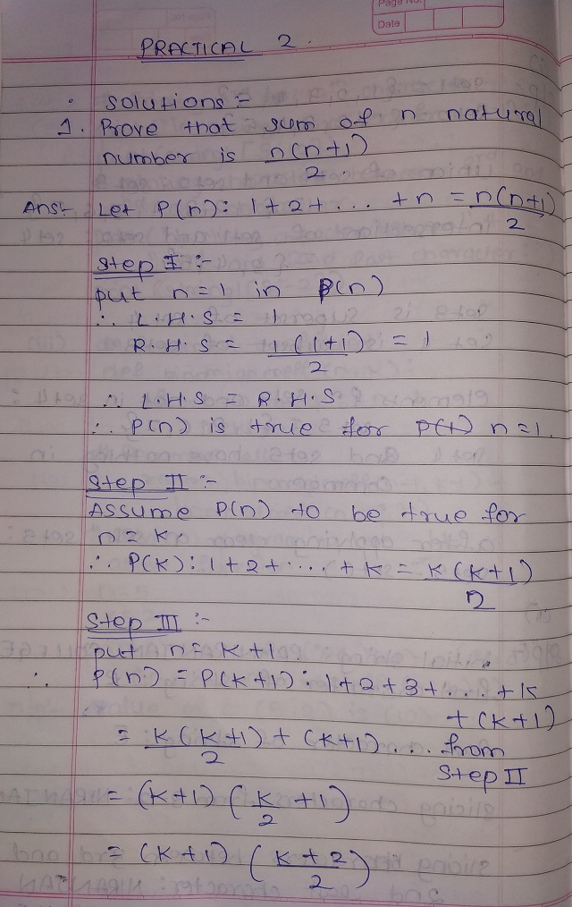

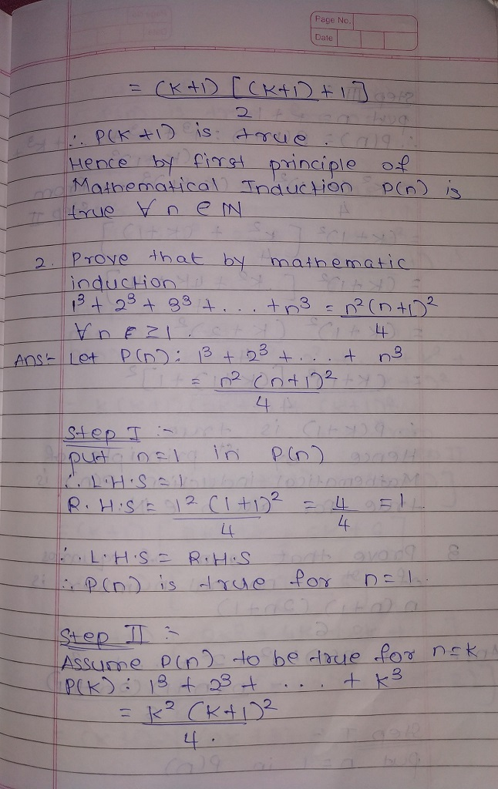

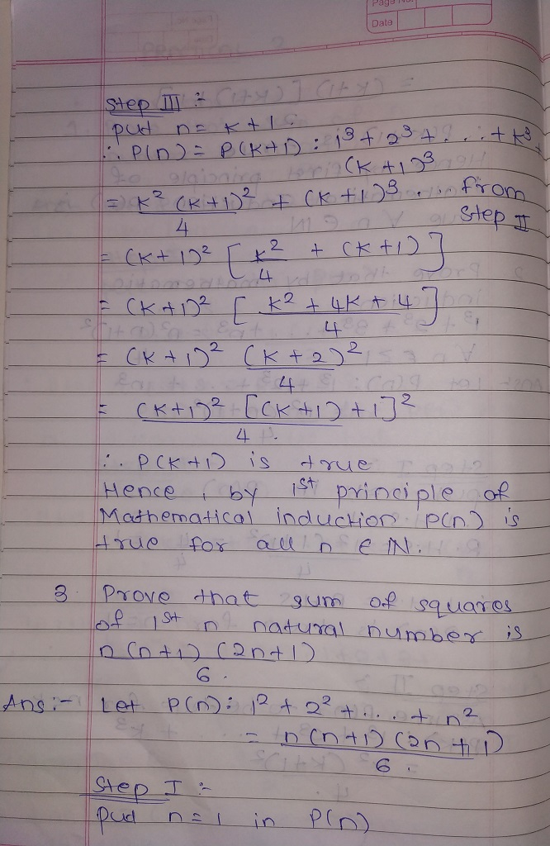

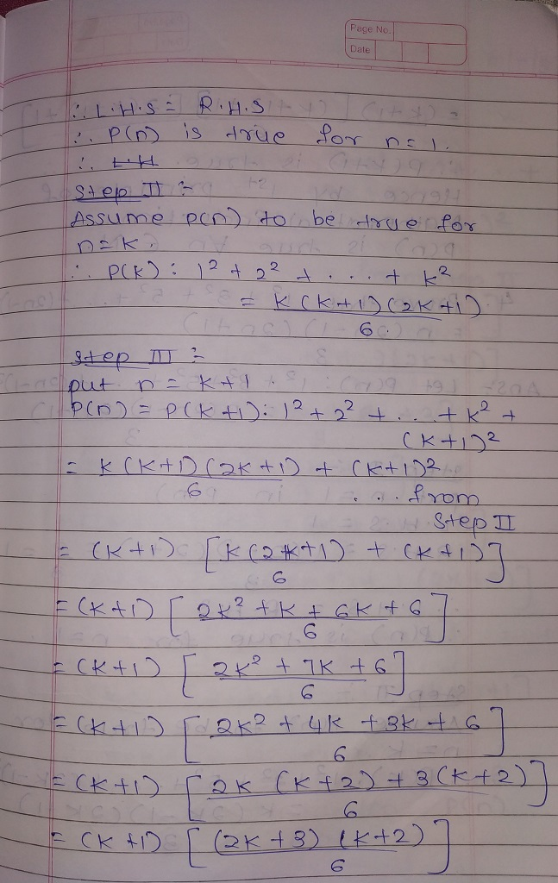

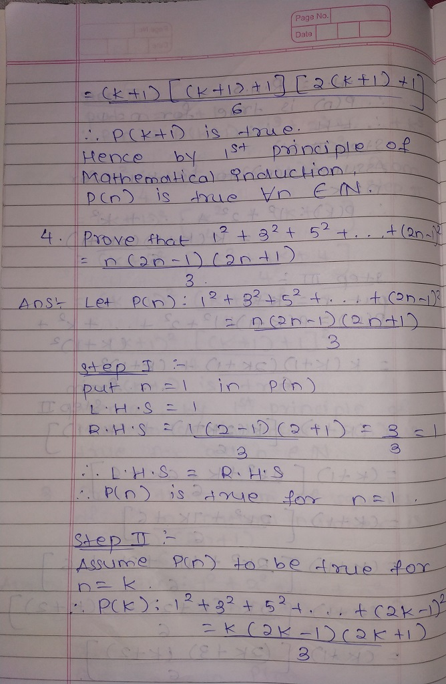

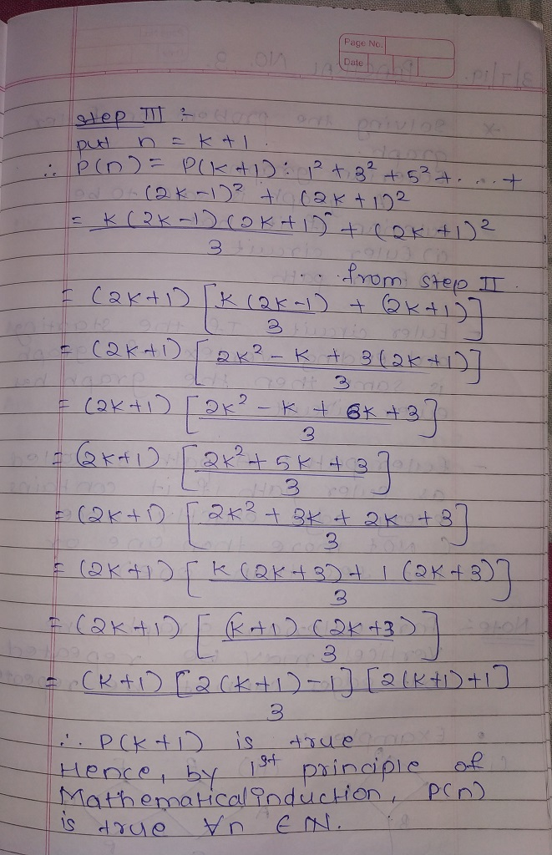

**PRACTICAL – 3**

**WRITE A PYTHON PROGRAM ON EULER GRAPH :-**

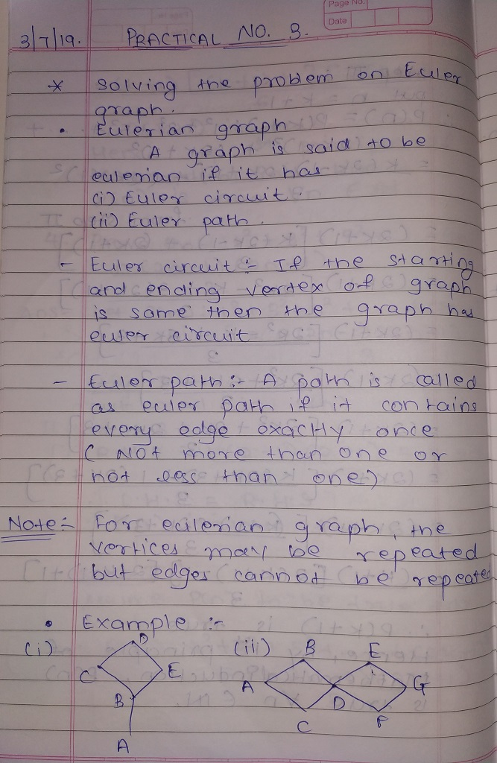

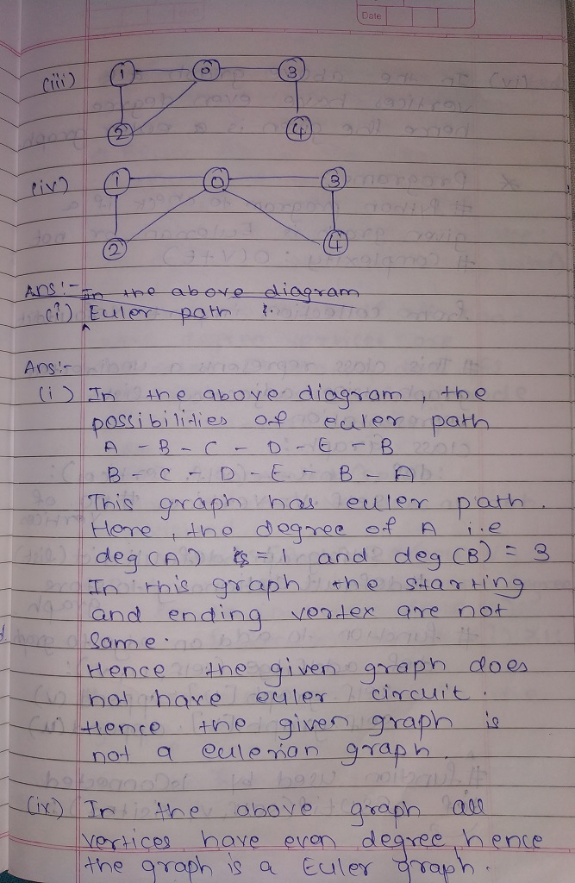

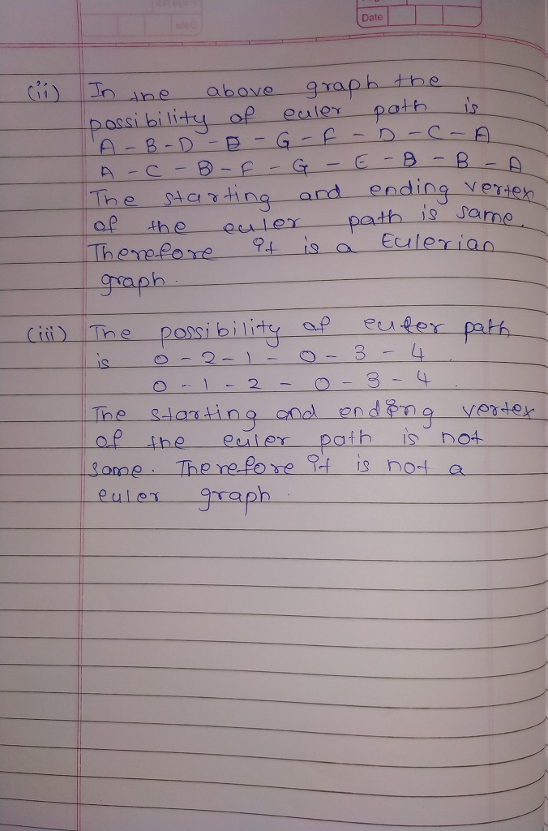

SOURCE CODE:

from collections import defaultdict

class Graph:

def __init__(self,vertices):

self.V=vertices

self.graph=defaultdict(list)

def addEdge(self,u,v):

self.graph[u].append(v)

self.graph[v].append(u)

def DFSUtil(self,v,visited):

visited[v]=True

for i in self.graph[v]:

if visited[i]==False:

self.DFSUtil(i,visited)

def isConnected(self):

visited=[False]*(self.V)

for i in range(self.V):

if len(self.graph[i])>1:

break

if i==self.V-1:

return True

self.DFSUtil(i,visited)

for i in range(self.V):

if visited[1]==False and len(self.graph[i])>0:

return False

return True

def isEulerian(self):

if self.isConnected()==False:

return 0

else:

odd=0

for i in range(self.V):

if len(self.graph[i])%2!=0:

odd +=1

if odd==0:

return 1

elif odd==2:

return 1

elif odd>2:

return 0

def test(self):

res=self.isEulerian()

if res==0:

print("graph is not eulerian")

elif res==1:

print("graph has a eulerian path")

else:

print("graph has a eulerian cycle")

g1=Graph(3)

g1.addEdge(1,0)

g1.addEdge(1,2)

g1.addEdge(2,1)

g1.addEdge(2,0)

g1.test()

OUTPUT:

graph has a eulerian path

**PRACTICAL – 4**

**SOLVING PROBLEMS ON HAMILTONIAN GRAPH :-**

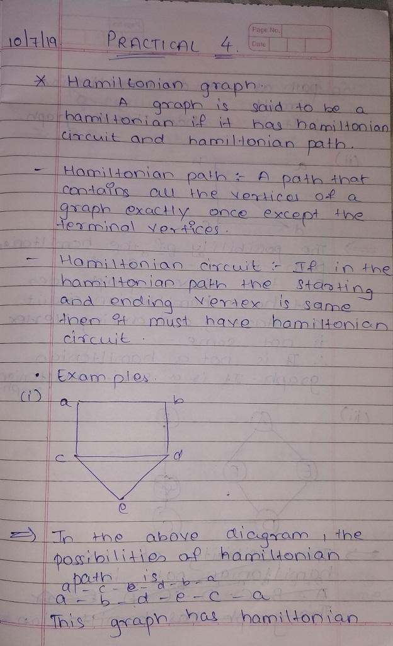

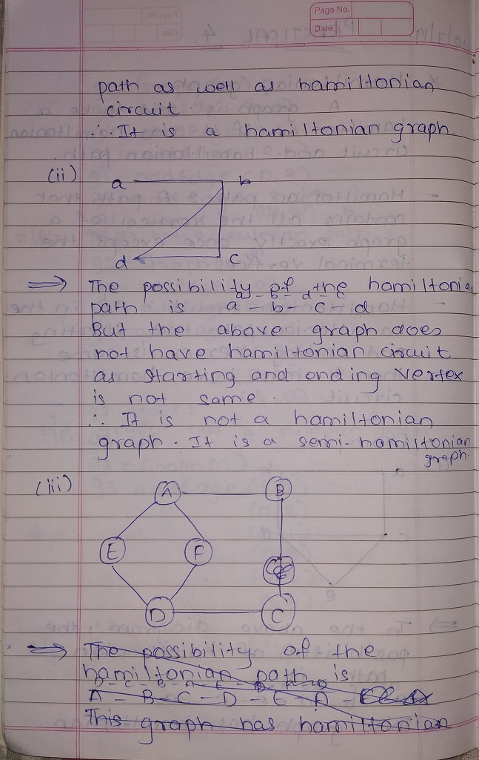

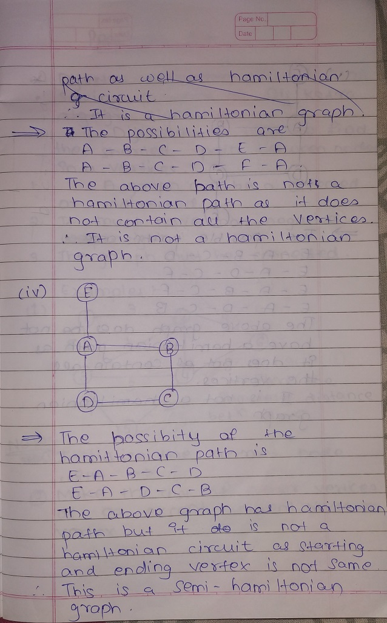

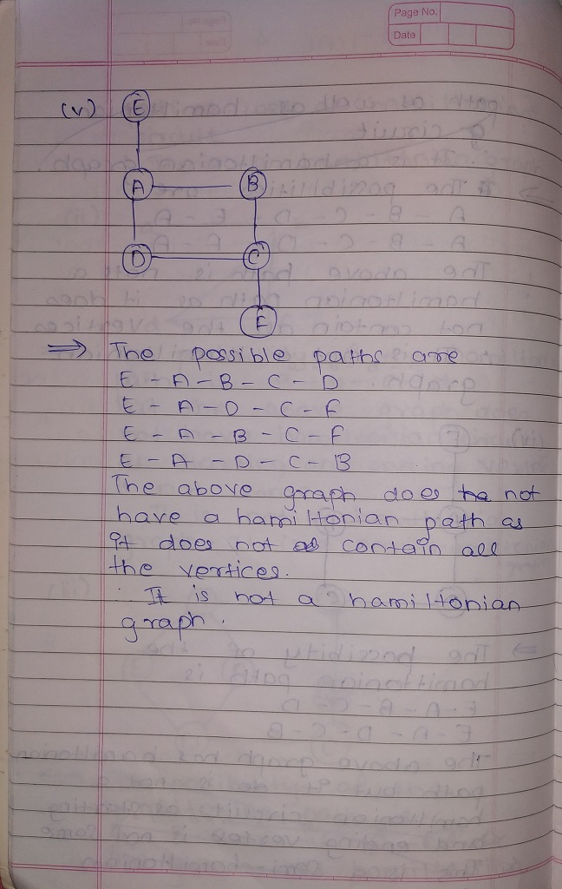

**PRACTICAL – 5**

**SOLVING PROBLEMS USING KRUSKAL’S ALGORITHM :-**

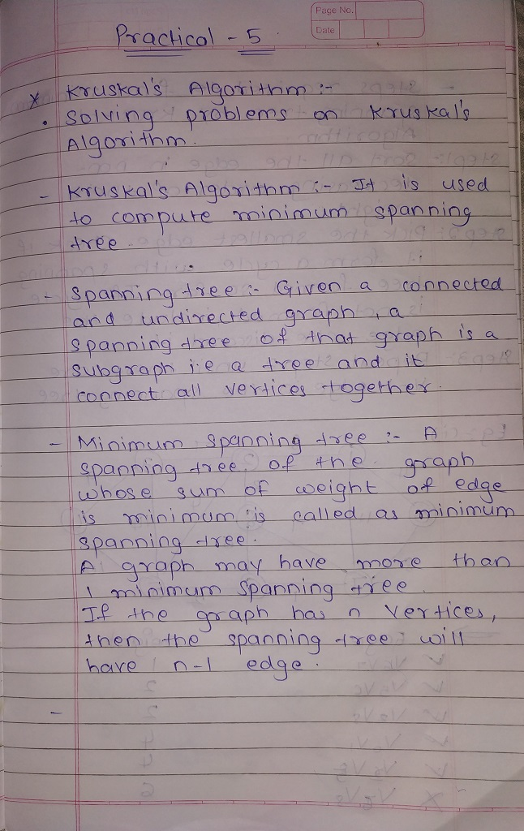

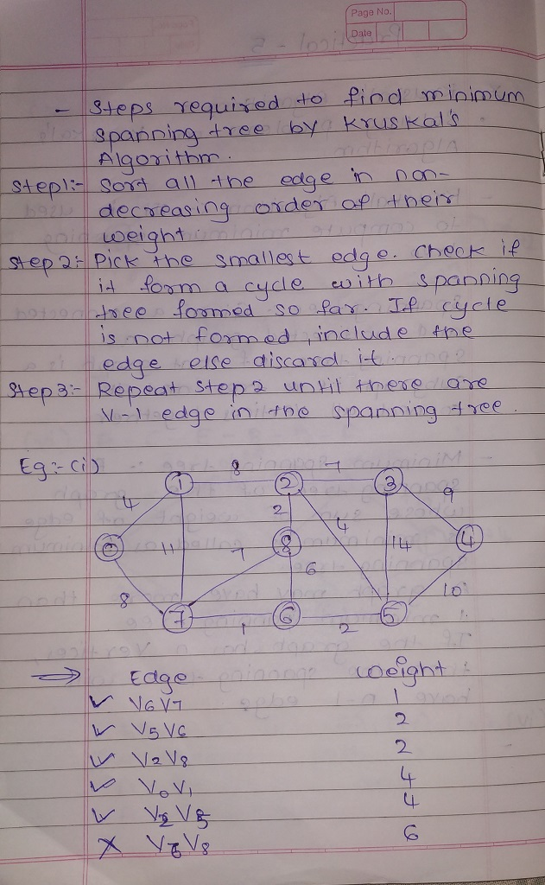

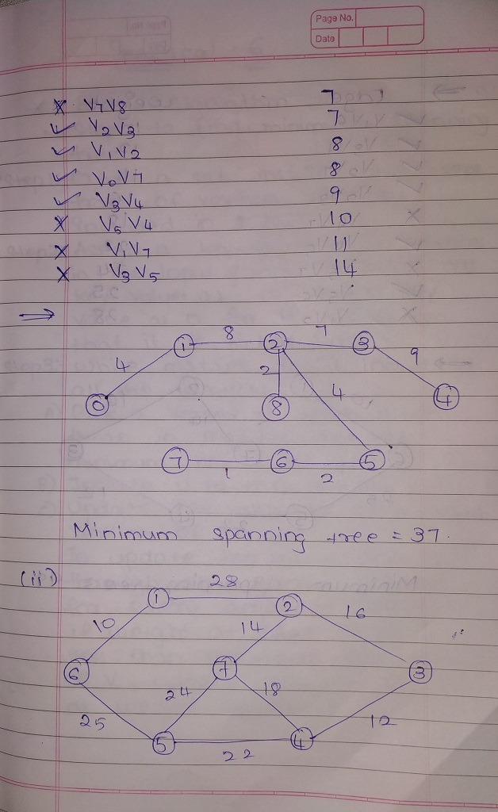

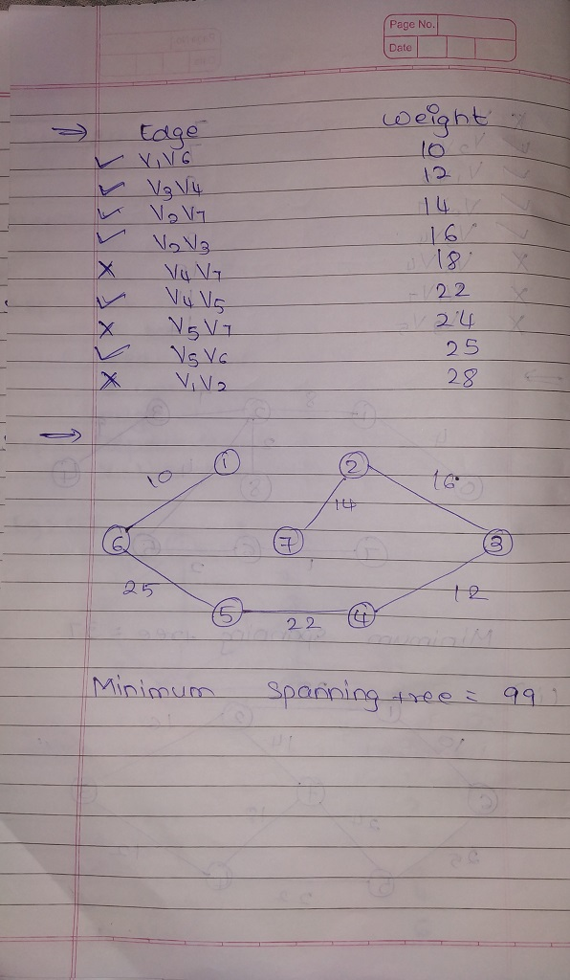

**PRACTICAL – 6**

**SOLVING PROBLEMS USING PRIM’S ALGORITHM :-**

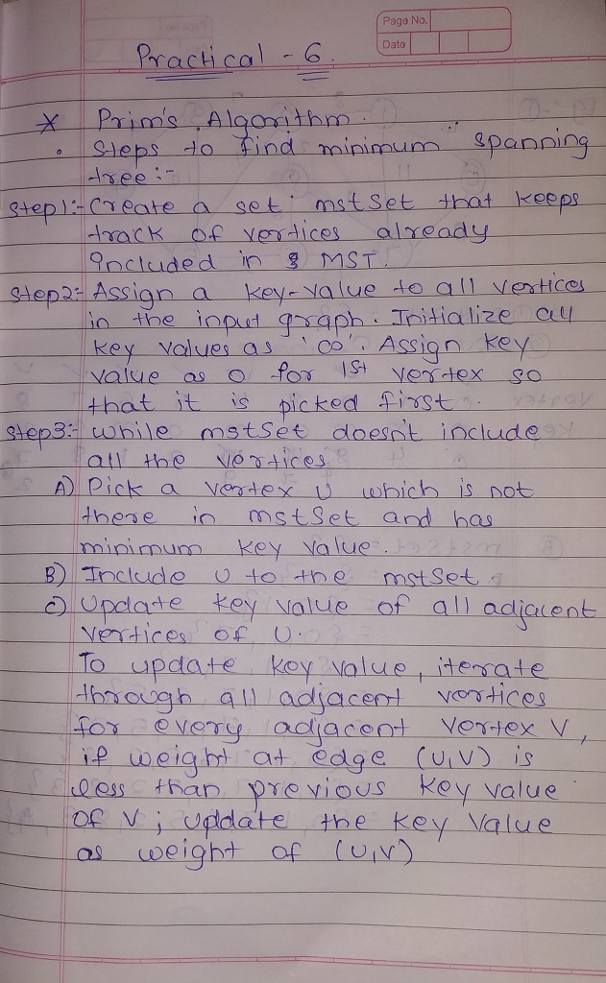

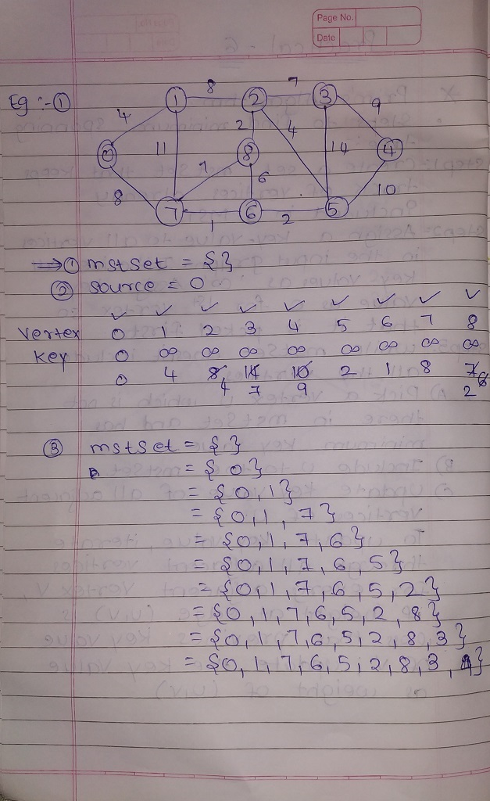

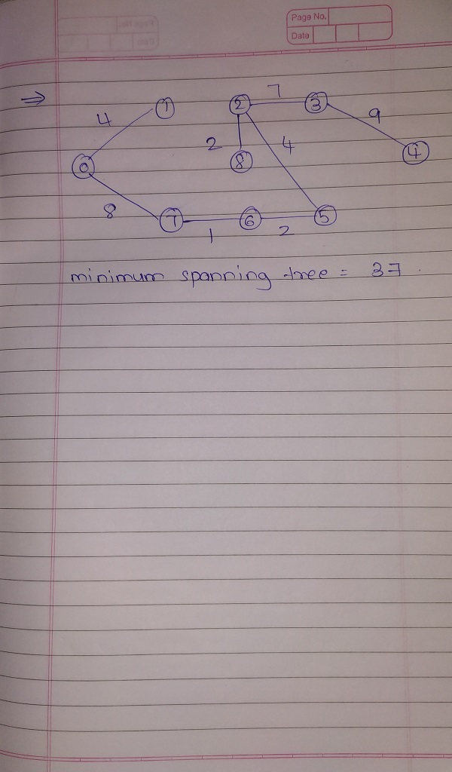

**PRACTICAL – 7**

**SOLVING PROBLEMS USING DIJIKSTRA’S ALGORITHM :-**

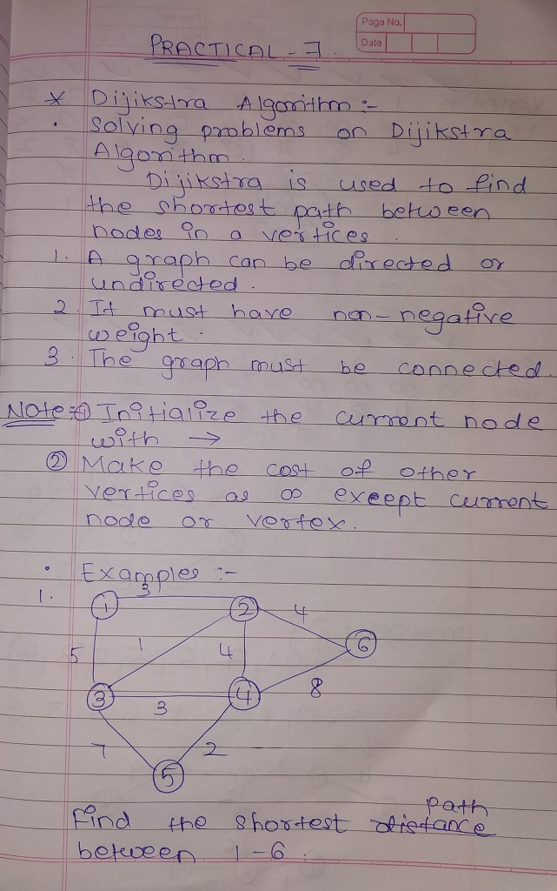

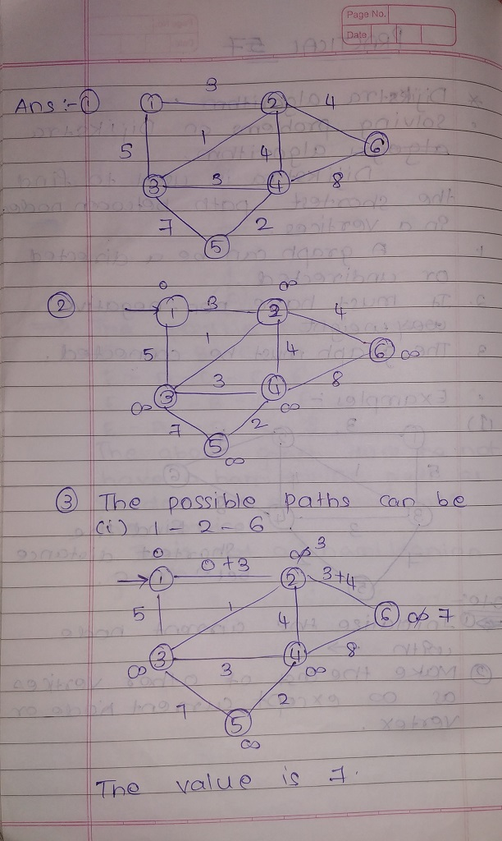

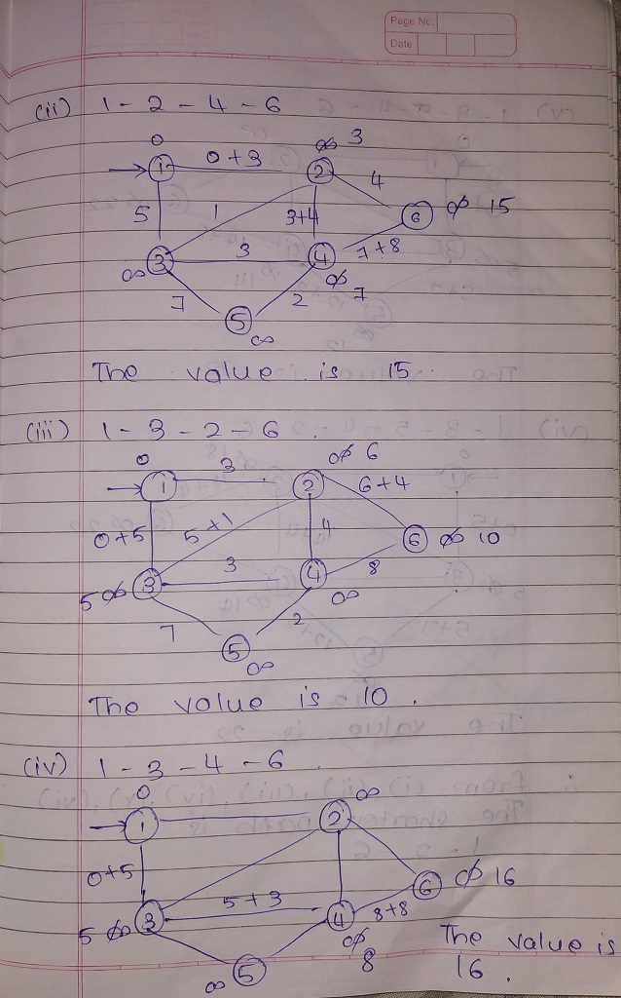

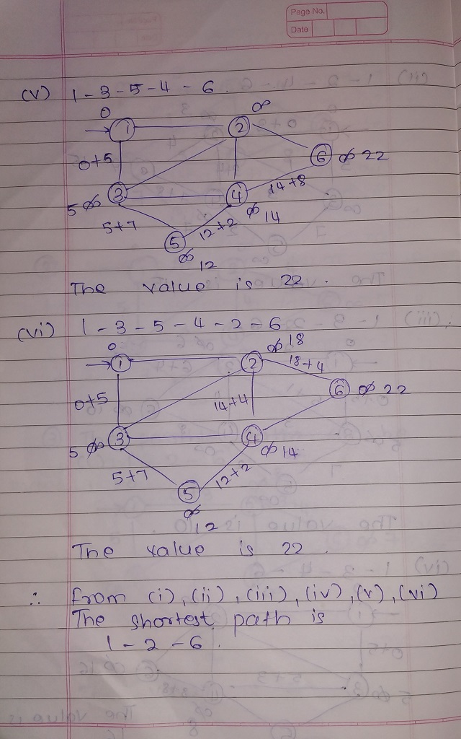

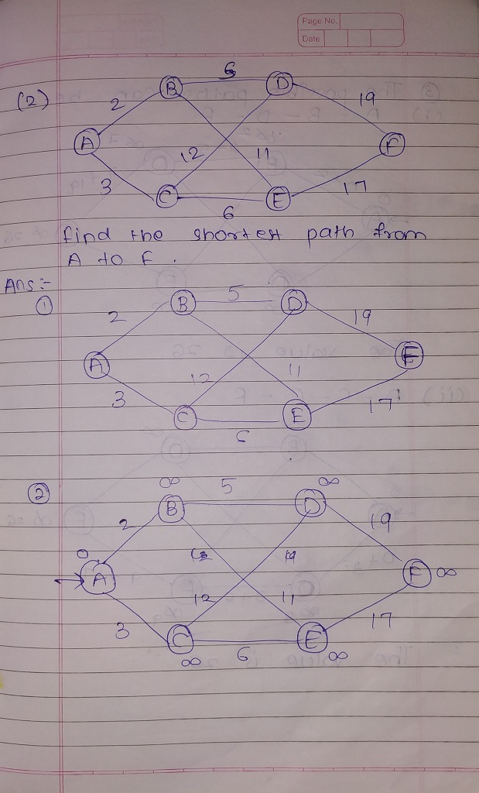

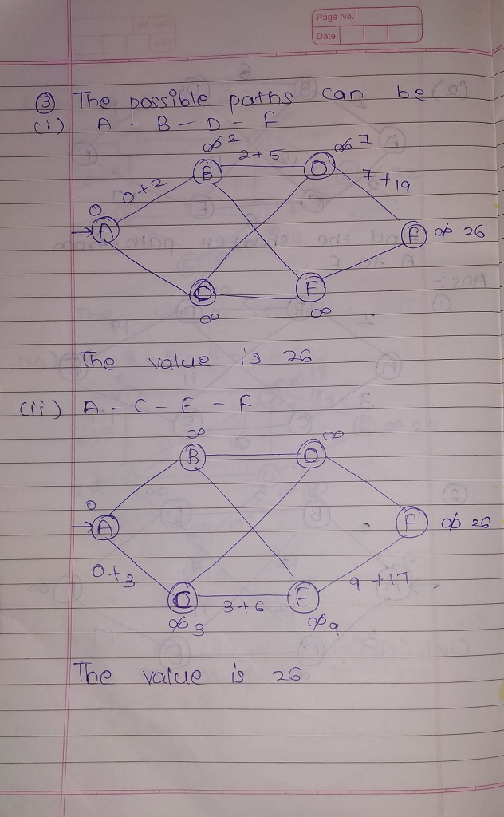

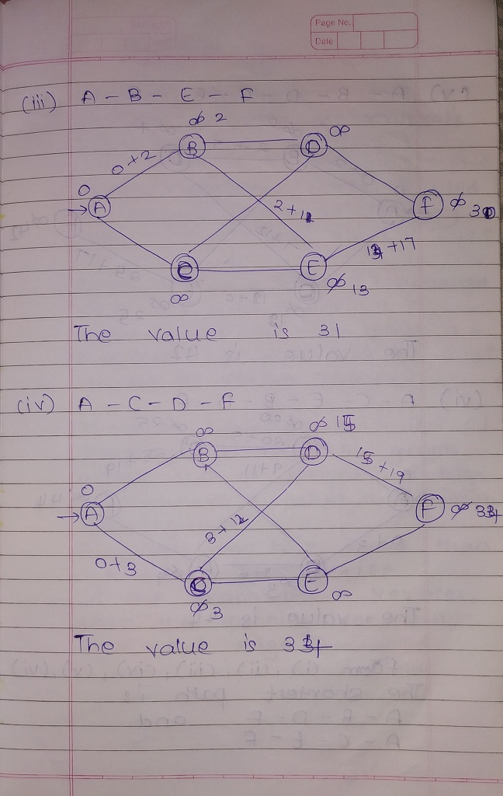

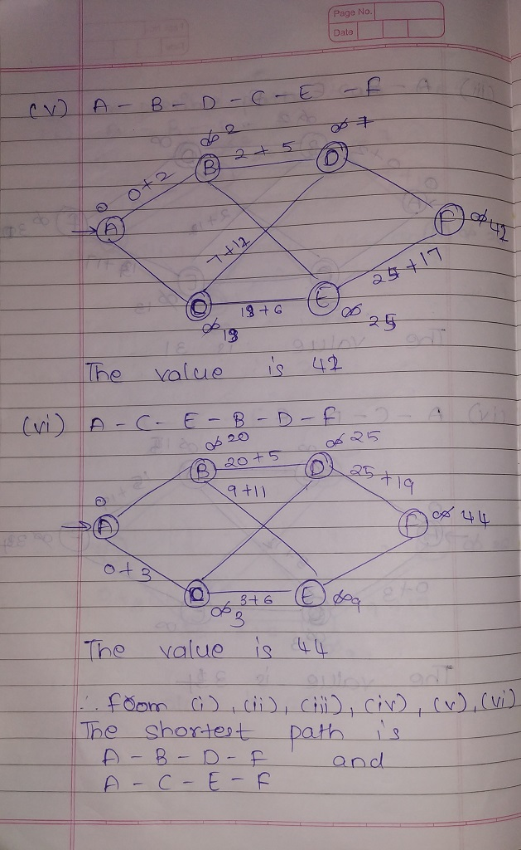

**PRACTICAL – 8**

**SOLVING PROBLEMS USING BELLMAN – FORD ALGORITHM :-**

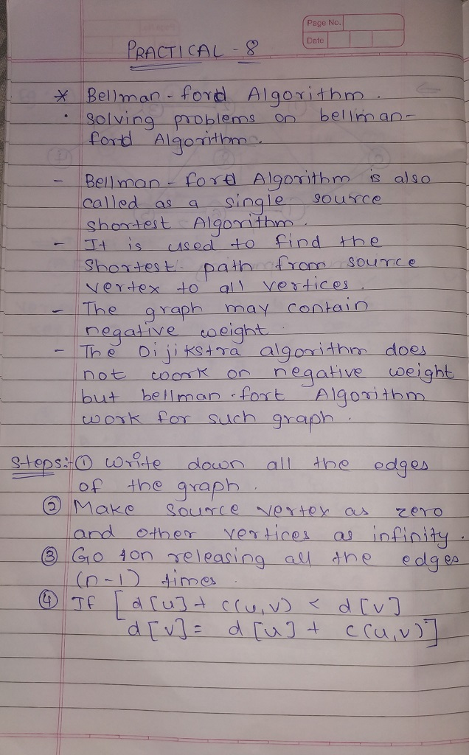

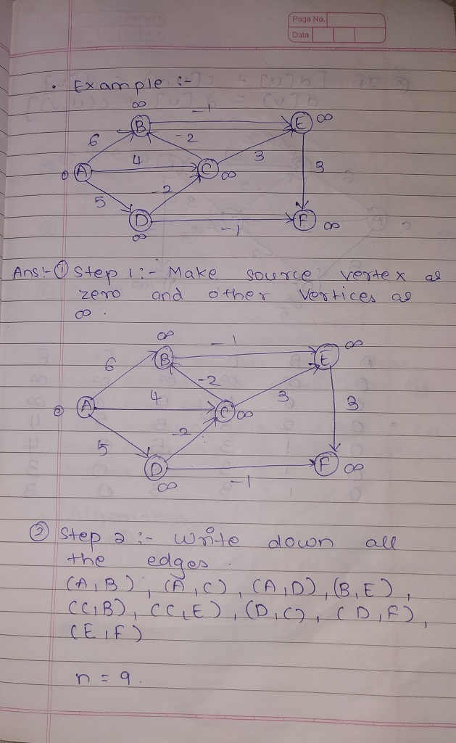

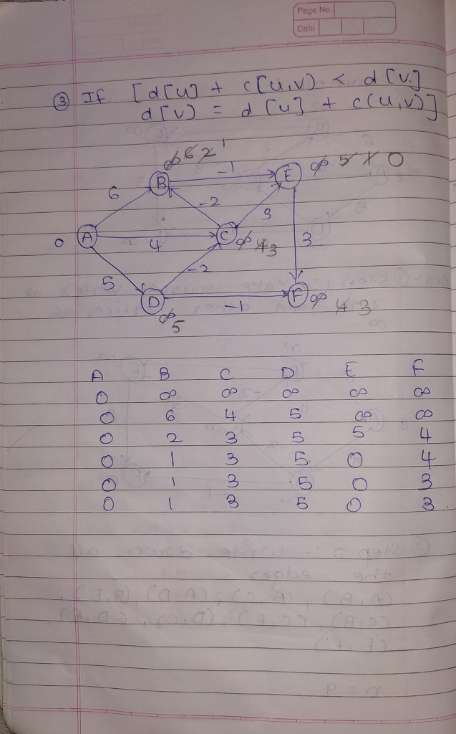

**PRACTICAL – 9**

**SOLVING PROBLEMS USING FORD – FULKERSON ALGORITHM :-**

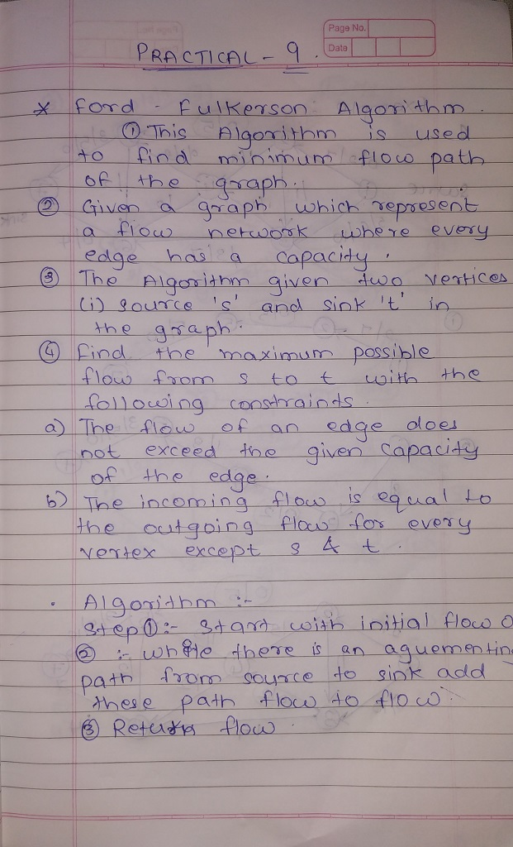

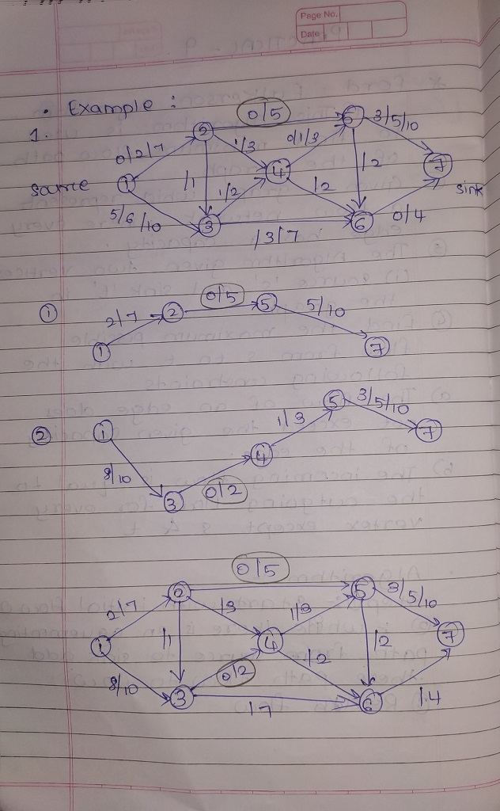

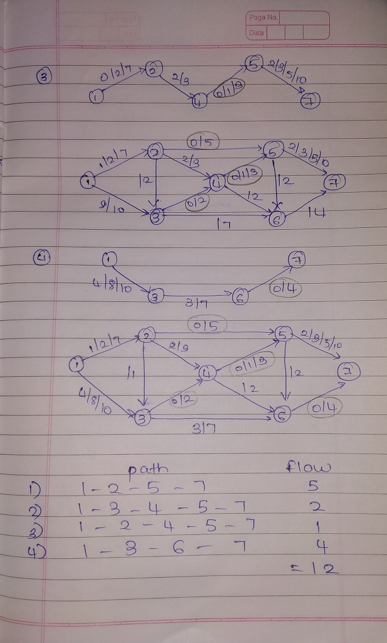

**PRACTICAL – 10**

**Solving Problems on Travelling Salesman Problem.**

